**DNS SERVER CONFIGURATION**

LOCAL INFRASTRUCTURE USED

MACHINE: DELL Inspiron 14 Laptop

CONFIG: Core I3, 2.00GHZ CPU, 4GB RAM, 1TB HDD

OS: REDHAT Linux el7.0.

Package & Conf files

Package: Bind 9.9.4

Configuration File: /etc/named.conf

Service & Daemon: named.service

Port: 53/TCP, 53/UDP

Configuration Check utility: named-checkconf

Basic Scenario: configure **server.example.com** as DNS server. It should resolve host names for other clients.

Domain = example.com

IP = 10.0.2.12

Hostname = server.example.com

**Step 1** : set IP and DNS as static then check /etc/resolv.conf. If it’s not as per dns entry change. it should look like below,

vim /etc/resolv.conf

search example.com

nameserver 10.0.2.12

**Step 2** : install bind package

yum install bind –y

**Step 3** : Edit /etc/named.conf

vim /etc/named.conf

(in “listen-on port 53“ entry add server hostname and in “allow-query” section type “any” so all can query this server)

listen-on port 53 { 127.0.0.1; 10.0.2.12; };

allow-query { any; };

(it will look like below image)

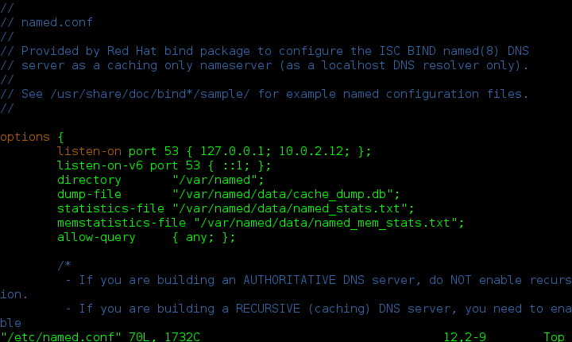

**Step 4** : enter zone file entries in /etc/named.conf as below

vim /etc/named.conf

(Enter zone entries as below)

(forward zone entry)

zone “example.com” IN {

type master;

file “forward.example”;

};

(Reverse zone entry)

zone “2.0.10.in-addr.arpa” IN {

type master;

file “reverse.example”;

};

(Comment file /etc/named.rfc1912.zones)

# include “/etc/named.rfc1912.zones”;

(File will look like below)

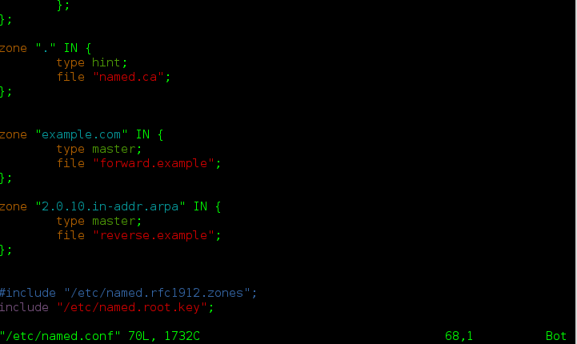

**Step 5** : (zone files default location is **“/var/named/”** , create 2 files **forward.example** and **reverse.example** then edit as per requirement)

(Forward file entry)

vim /var/named/forward.example

type contents as below image and save file.

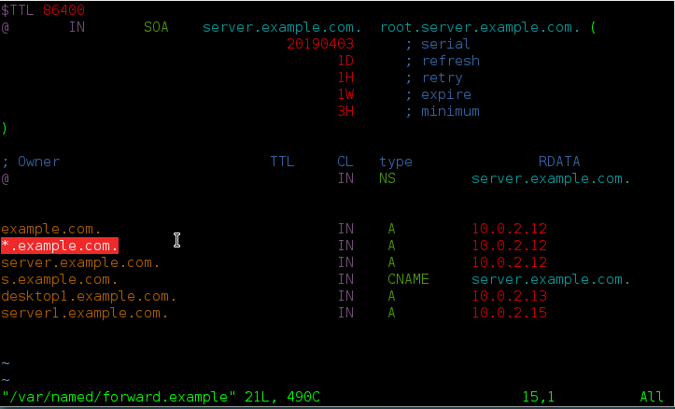

(Reverse file entry)

vim /var/named/reverse.example

Type contents as below image and save file.

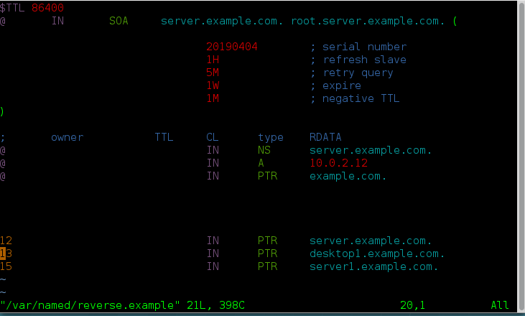

(Check configuration and zone files using “named-check” function)

named-checkconf /etc/named.conf

named-checkzone localhost /var/named/forward.example

named-checkzone localhost /var/named/reverse.example

**Step 6** : enable and start service

systemctl enable named.service

systemctl start named.service

**Step 7** : add port 53 in firewall

firewall-cmd –add-port=53/tcp –permanent

firewall-cmd –add-port=53/udp –permanent

firewall-cmd –reload

systemctl restart named.service

**Step 8** : server configuration completed check using nslookup or dig.

(Change client dns IP as 10.0.2.12 and edit “/etc/resolv.conf” then check)

**OUTPUT**

